

**Car Price Prediction Project**

Submitted by:

N THARANI

**ACKNOWLEDGMENT**

Various research papers and websites are used. Research papers like Impact of Covid-19 on Automobile Industries in India - [A Xavier Susairaj](https://www.researchgate.net/profile/A-Xavier-Susairaj), [A. Salaijayamani](https://www.researchgate.net/profile/A-Salaijayamani), [Premkumar A.](https://www.researchgate.net/profile/Premkumar-A), [An impact study of COVID‐19 on six different industries - J Nayak,](https://www.ncbi.nlm.nih.gov/pmc/articles/PMC8014102/) Covid Economics, Covid-19 impact on transport, Impact of Covid 19 on the automotive market. Website like cars24/blog, researchgate.net, dnaindia.com, geeksforgeeks, economictimes, stackoverflow.com, etc., are used as references. The data is received from the client which is their own data.

Thanking SRISHTI MAAN, my guide from FLIPROBO TECHNOLOGIES for clearing all my doubts while undergoing the project.

**INTRODUCTION**

* Business Problem

There are a lot of changes in the car market because of the impact of covid 19. With the change in market due to covid 19 impact, everyone is facing problems with their previous car price valuation.

Our client is also facing issues in evaluating the car price. Now some cars are in demand hence making them costly and some are not in demand hence cheaper. These issues are not helping in finding the right approximate price of the used cars also. So, they are looking for new machine learning models from new data. We have to make car price valuation model.

* Conceptual Background of the Domain Problem

The COVID-19 outbreak has spelt havoc on the economies of almost every country in the world. The situation is no different in India, which has been hit by the global pandemic quite hard. Like all the industries, even the automobile industry has witnessed some heavy losses owing to the outbreak of this pandemic and the resultant lockdown.

“Prices of raw materials involving metals, plastics and others are up enormously. Since this year, the input costs are up sharply. The price hike has to happen. Higher costs cannot be held back. However, we have to maintain a balance between customer expectations and business prudence,” said by the experts.

* Review of Literature

Certain websites and papers that helped me to take insights from are:

1. Impact of Covid-19 on Automobile Industries in India - [A Xavier Susairaj](https://www.researchgate.net/profile/A-Xavier-Susairaj), [A. Salaijayamani](https://www.researchgate.net/profile/A-Salaijayamani), [Premkumar A.](https://www.researchgate.net/profile/Premkumar-A)
2. [An impact study of COVID‐19 on six different industries - J Nayak](https://www.ncbi.nlm.nih.gov/pmc/articles/PMC8014102/)
3. Covid Economics
4. Covid-19 impact on transport
5. Impact of Covid 19 on the automotive market

* Motivation for the Problem Undertaken

Automobile industries sales have came down during this pandemic period created by covid 19. This pandemic has affected leading car selling industry in India. New entries into India automobile market has also affected. Only some industries have hiked up from the pandemic and some still lays in the downward phase.

The main motivation of this project is that the automobile industry has faced many issues during this pandemic and it is now striving up. People is in need to buy cars since the pandemic is over and everything is coming back to normal. It is in need for people to analyse the price of the cars.

**Analytical Problem Framing**

* Mathematical/ Analytical Modeling of the Problem

Various statistical, mathematical, analytical algorithms are used. Experimental design, outliers detection using Z-score, transformation, scaling, re-sampling methods, statistical hypothesis tests, estimation statistics, data manipulation, feature selection, feature reduction, balancing the dataset, etc are done for the problem.

* Data Sources and their formats

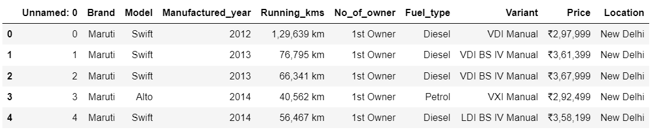The data is scraped from cars24.com with necessary data description. The data is scraped and saved as a dataframe which can be used later. This data is saved in csv format in the local system. The data is about 6332 rows in total. The .csv format file can be imported using pandas from local library easily.

* Data Preprocessing Done

Columns like unnamed:0 are not necessary. Based on the data description, features which does not help to determine the car price detection are removed. unnamed:0 is a feature which has the same data for the whole dataset which will not help in determining the result. Convert price and running kms into integer type from string type. Check for null values, string data type to encode. Check for outliers and check the curve for normalization. Correlation and multi collinearity are checked and treated.

* Data Inputs- Logic- Output Relationships

There are various features used to detect the defaulter. All the features which are helping to detect the defaulter is visualised using matplotlib and seaborn. The relationship between the features are determined. After data cleaning, the relationship between input and output variables is fairly linear.

* State the set of assumptions (if any) related to the problem under consideration

In automobile industry, everything is biased in nature on predicting the price of a new car coming into market. Here, we are predicting the price of used cars after pandemic. So, certain measures are considered like economic falldown, new electric cars into the market, etc., So, predicting the price of used cars would be easy.

* Hardware and Software Requirements and Tools Used

Any laptop and computer can be used as hardware. Processor used is Intel(R) Core(TM) i7-4510U CPU. System type is 64-bit operating system, x-64 based processor. RAM of the systerm is 8.00 GB. Microsoft Windows 8.1 version 6.3 is the OS used. Python 2.7.10 is used with the interface Jupyter notebook with many installed libraries.

**Model/s Development and Evaluation**

* Identification of possible problem-solving approaches (methods)

There are statistical and analytical approaches in problem-solving. Data cleaning, data mining, wrangling comes under statistical approach whereas data manipulation, feature selection, feature reduction, creating ML models comes under analytical approach.

**Statistical:**

* + - ***Experimental Design*** - Methods to design systematic experiments to compare the effect of independent variables on an outcome
  + Univariate - measure relies on only one variable - Statistical summary, information on variables, etc
  + Bivariate - measure relies on two variables - Correlation, multicollinearity
    - ***Outliers detection using Z-Score (z = (x-μ)/σ)*** - where x is the observed value, μ is the population mean, and σ is the population standard deviation
    - ***Transformation*** - Transformed the data using ordinal encoder for the data to be analysed
    - ***Scaling*** - Scaled the data using Standard Scaler to get unbiased result.
    - ***Re-sampling Methods*** - Train Test Split is used to systematically split a dataset into subsets for the purposes of training and evaluating this predictive model.
    - ***Statistical Hypothesis Tests*** - Cross validation quantifies the likelihood of observing the result given an assumption or expectation about the result whether the model is overfitting/underfitting or fitting good.
    - ***Estimation Statistics*** - GridSearchCV is used to quantify the best parameter from the listed to fit in the model and give better result. It uses data analysis framework which has a combination of effect sizes, confidence intervals, precision planning, and meta-analysis to plan experiments, analyze data and interpret results.

**Analytical:**

It concerns the design and development of algorithms.

* ***Data Manipulation*** - Check for skewness and if there is no more skewed data, not necessary to treat it.
* ***Feature selection*** - Check the relationship between independent and dependent variables. Select the features which gives meaning to the problem based on the subject knowledge.
* ***Feature reduction*** - Reduce the features which does not give proper solution to the problem using Principal Component Analysis. But, the data is scraped by us. So, all the variables are in need for the analysis.
* ***Balancing the dataset*** - Balance the dataset and normalize the data to get better result.
* Testing of Identified Approaches (Algorithms)

Various evaluation metrics can be used for this regression type of model. Some of the popular algorithms are the following:

* Linear Regression
* k-Nearest Neighbors
* Decision Trees
* Support Vector Machine
* Random Forest Regression
* Run and Evaluate selected models

Regression Score - Percentage of correct predictions for dataset

***Linear Regression:***

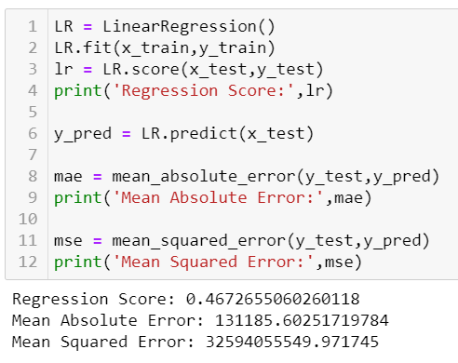

Regression Score - 0.46

***Decision Tree:***

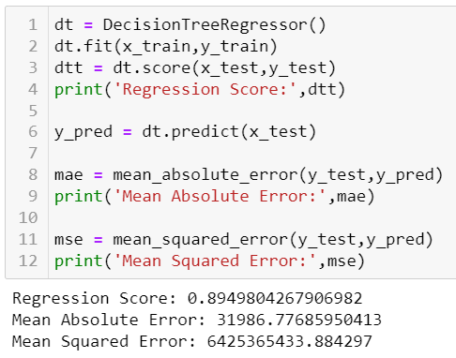

Regression Score - 0.89

***Random Forest Regressor:***

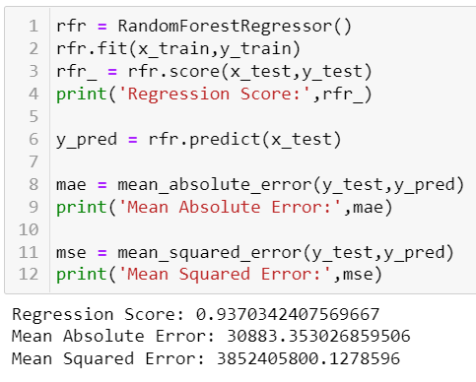

Regression Score - 0.93

***Support Vector Regression:***

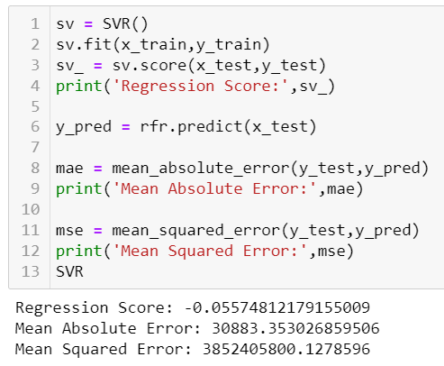

Regression Score - -0.05

***KNeighbors Regressor:***

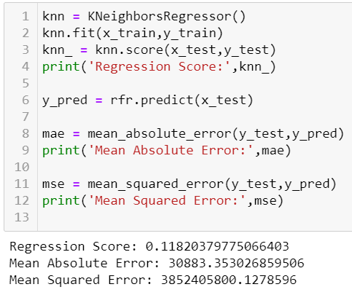

Regression Score - 0.11

* Key Metrics for success in solving problem under consideration

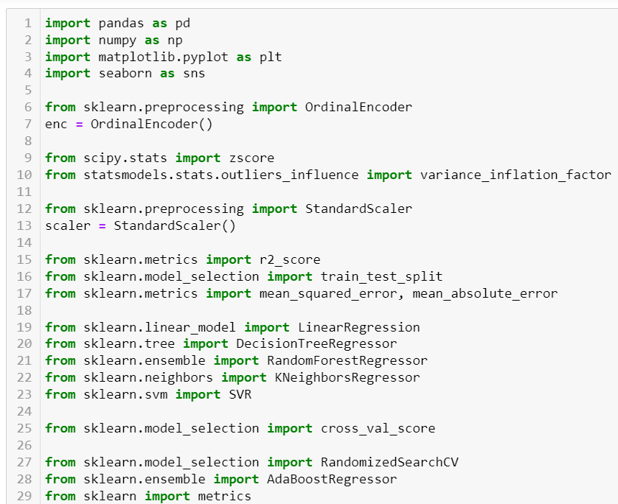

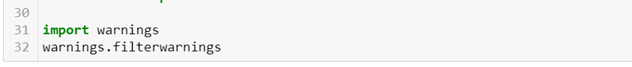

|  |  |
| --- | --- |
| **Libraries** | **Usage** |
| Pandas and numpy | Importing dataset, data cleaning, data wrangling and exploratory data analysis |
| Matplotlib and seaborn | Visualisation libraries |
| Ordinal Encoder | Encode the data from string to integers |
| Variance_inflation_factor | To check the multicollinearity |
| z-score | To check and remove outliers with fixed threshold |
| Standard Scaler | To standardise the data and normalise the curve |
| R2 score, mean_squared_error, mean_absolute_error | For concluding the results |
| Train_test_split | To separate the training and testing dataset |
| Linear Regression, DecisionTreeRegressor, RandomForestRegressor, SVR, KNeighborsRegressor | All these are machine learning algorithms to find the results |
| Cross_val_score | To check the best fitting of the model |
| RandomisedSearchCV | For hyper parameter tuning |
| AdaBoostRegressor | The weights of instances are adjusted and checks the fitting of model by applying the estimators |
| Metrics | It is used to track the performance by quantitatively assessing |

* Visualizations

Matplotlib and seaborn is used for visualisations

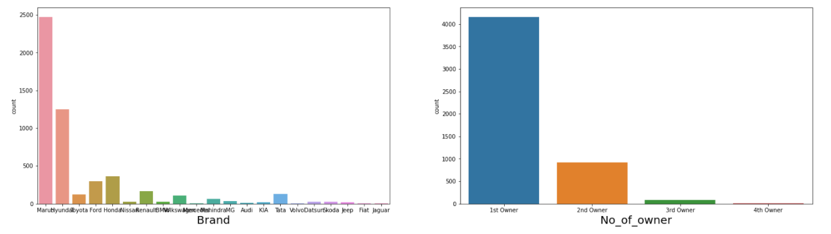

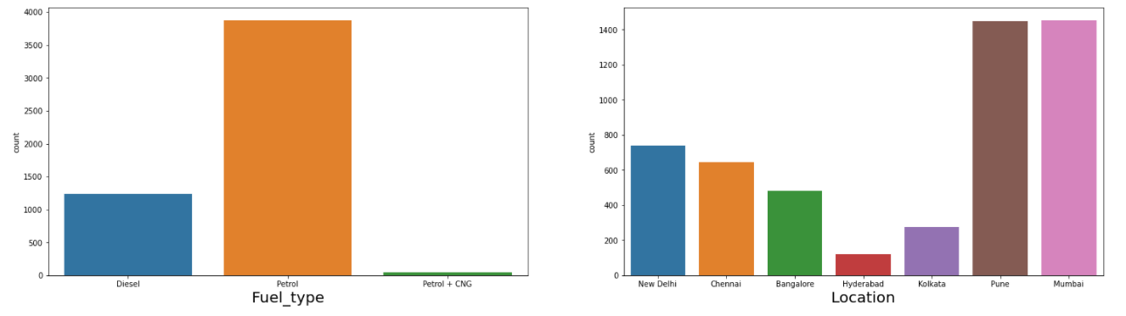

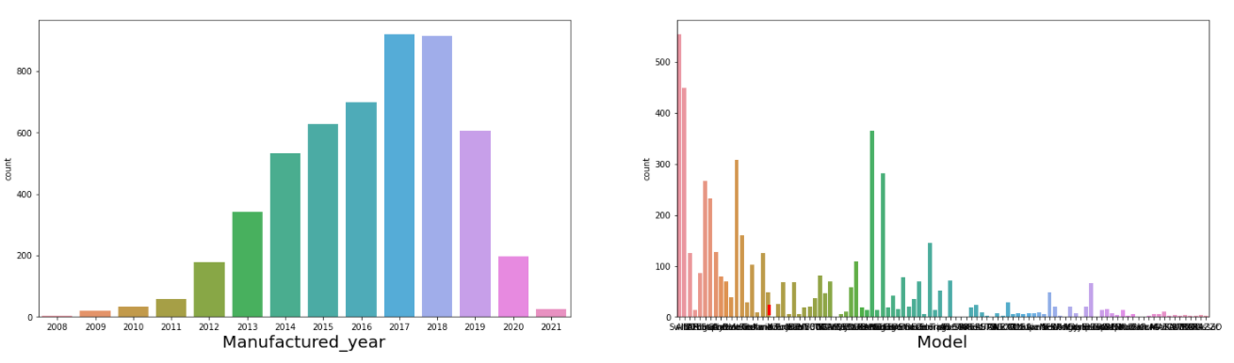

Categorical variables are visualized separately to understand the distribution where the target is imbalanced using countplot.

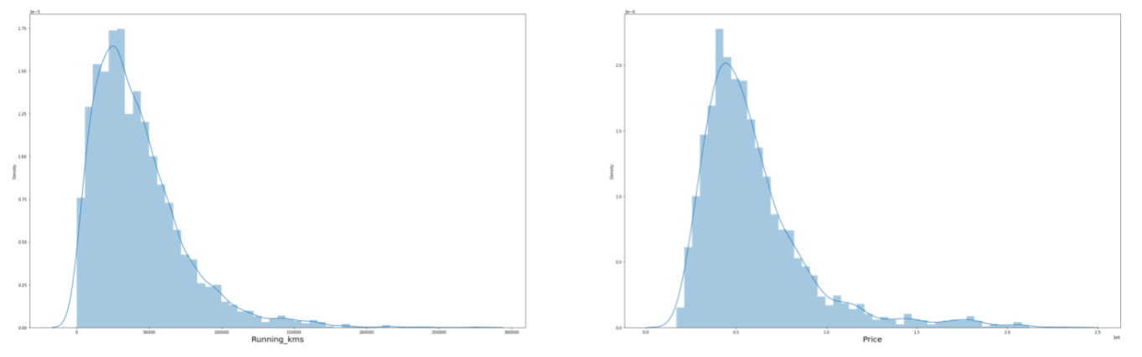

Continuous variables are visualized separately to understand the distribution where they are normally distributed.

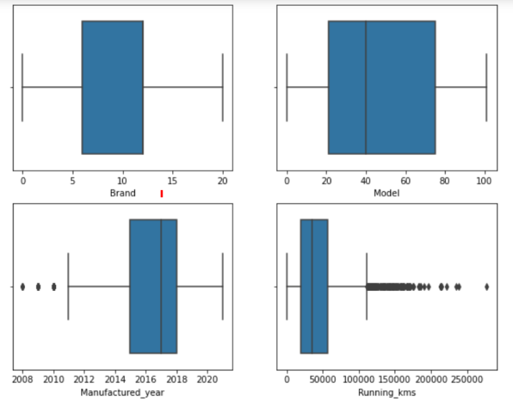 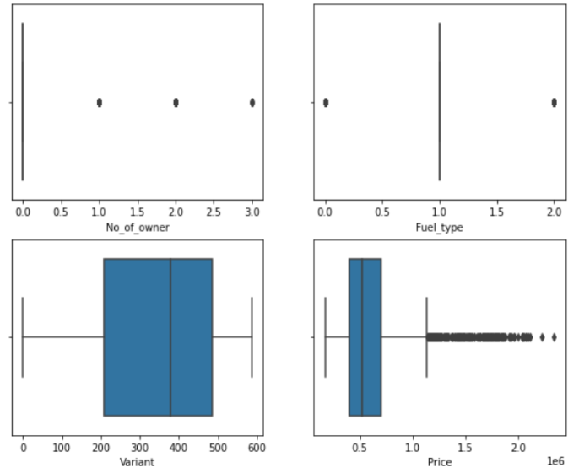

To detect outliers boxplot is used which showed many outliers

* Interpretation of the Results
* Categorical variables and continuous variables are visualized separately to understand the distribution where the target is continuous in nature with the other variables are normally distributed
* To detect outliers boxplot is used which showed many outliers
* The relationship between dependent and independent variables are visualised where it looks fairly linear
* In data preprocessing, duplicates are removed which helps to get unbiased result

**CONCLUSION**

* Key Findings and Conclusions of the Study

The relation between the input and output variables looks fairly linear after data cleaning. There is no correlation and multicollinearity. Vif is use to select the features where they are selected to get better results. From the models, random forest regressor gives better result and also on comparing the cross validation the model fitted well.

Hyper parameter tuning is also done to check whether the accuracy can be improved, but it doesn't.

* Learning Outcomes of the Study in respect of Data Science

Visualising the categorical and continuous variable tells how the variable is distributed and the balancing of the dataset. Checked the correlation. The data already does not have null value and the data is encoded using ordinal encoder.

Decision tree and Random Forest Regressor is good to go with the model. Random forest regression, KNN takes time for training. SVR takes very long time to train the model. Cross-validation took time to complete and checked whether the model is underfitting and overfitting the model.

Random Forest Regressor gave 93% Regression score approximately. Even after hyper parameter tuning, the model score did not increase. So, we can use Random Forest Regressor for further predictions.

* Limitations of this work and Scope for Future Work

We have got 93 as the regression score with cross validation score as 91. There is scope to improve the cross validation score with the model score.